

Operating Instructions

DOD GS980D

Safety measures

**Product**

* Do not disassemble, repair, modify the dashcam or power related accessories. Contact DOD Technical Support for warranty service.
* Do not adjust or use the dashcam while driving.
* Avoid prolonged exposure of the dashcam to moisture and/or heat.
* Prolonged exposure can shorten the life of the product.
* Do not spray water or detergents directly into the camcorder.
* Liquids can cause fire, electrical shocks or malfunctions.
* Avoid installing a camera where it could obstruct the driver's view or a deployed airbag.

**Car adapter**

* Use only the DOD power adapter supplied with your unit.
* Other power adapters may create a safety hazard or damage the unit.
* Do not use damaged power adapters or cords. If damaged, disconnect the power adapter and contact DOD Technical Support for assistance.
* Do not pull, insert or bend the power cord with excessive force.
* Do not use the mains cable and do not work with wet hands.
* In specified vehicles, power can still be supplied to the device even when the engine is switched off. The vehicle battery may be discharged. The DOD DP4 accessory kit, equipped with low protection, is designed to prevent battery discharge and reserve the minimum voltage required for shutdown.

**Supercapacitor**

* Keep the device away from heaters or other hot objects.
* If the camera is not working, keep the jupred at lower temperatures to prevent damage to the supercapacitor.
* Only power the camera with the original power cord.

**Other**

* Test the MicroSD memory card regularly, as the memory card is a consumable and needs to be replaced regularly.
* Format the memory card in the camcorder menu every two weeks to extend its life. You should only do this after you have downloaded any files from the card that you want to keep, as formatting the memory card will erase all files.
* DOD is NOT responsible for any malfunctions that occur from the use of unauthorized, modified, or unauthorized parts and accessories.
* DOD DOES NOT warrant the recording of accidents that may cause equipment failure and malfunction.
* The working temperature of this product is -20°C to 65°C (-4°F~149°F). Please make sure the device is stored within the temperature range, otherwise the device may be damaged by heat and will malfunction, which will not be covered by warranty.
* DOD is not responsible for the loss of recorded video during operation due to unexpected factors while driving.
* The video footage produced by this camera is for personal use only.

Before starting

**Setting up your camera**

Set up the dashcam in the vehicle so that the power is easily accessible. Ensure that the front and rear cameras are connected during use.

**1. Start with the SD card**

Before inserting the memory card, we recommend to start the camera without it and after switching it on, start the wifi so you can connect to the camera and disable the auto recording function in the camera settings. This function is used to automatically start recording when the wifi is connected, but when initially formatting the memory card this function may prevent you from changing the camera settings. After formatting, the function can be enabled again. All memory cards need to be formatted in the camera for proper device functionality. **Memory cards with the eXFat file system must always be formatted before first use (cards with a capacity of 64GB and above).**

C:\Documents and Settings\sophie\桌面\無標題-1.epsTo store recorded video footage stably, it is recommended to format the SD card every two weeks (this option is in the camera menu).

|  |  |  |  |  |  |  |  |  |  |  |  |  |  |
| --- | --- | --- | --- | --- | --- | --- | --- | --- | --- | --- | --- | --- | --- |
| |  |  | | --- | --- | |  |  | | *Note: Requires a MicroSD Class 10 or higher card, supports up to 256GB.For proper camera functionality, use only tested memory cards from Kingston or Samsung.* ***It is not recommended to use Sandisk cards or cards from other manufacturers. This may cause the camera to malfunction.***  *Note: After formatting the SD card, all your data will be deleted. Make sure you have backed up your important files.*  **Length of recording**   |  |  | | --- | --- | | Storage/Quality | 1080p recording length | | 16GB | 110 minutes (1.8 hours) | | 32GB | 200 minutes (3.2 hours) | | 64GB | 380 minutes (6.3 hours) | | 128GB | 780 minutes (13 hours) |   *\*Duration of video recording may vary depending on environmental conditions.* |

Camera control

**Power button [** **]**

Press and hold to switch the camera on/off.

**Emergency SOS file lock [** **]**

During recording, press the SOS button - this prevents the file from being overwritten afterwards.

**Menu button [ ]**

Enter MENU. During playback - pause/stop playback of the file.

**Wifi connection [** **]**

Turn WiFi on: press and hold for 5 seconds to turn WiFi on.

Turning off WiFi: Blue prompt screen, click [**OK**] and a beep will sound, after about 2 seconds it will automatically return to the recording screen.

Note: Recording will be interrupted when Wi-Fi is turned on.

**Directional keys **

In the menu - select the desired item

During playback - use arrow keys to rewind/forward

**Microphone [** **]**

**Press【C:\Users\mimi\Desktop\mic.wmf 】button** once to turn voice recording on/off.

**Button screen [** **]**

Switch between image display modes

**Recording / Confirmation [OK]**

When recording - stops recording

During playback - pauses or starts playback

In the menu - used to confirm the selection

**RESET button**

Press to force a reboot of the device

**USB interface [2CH**]

USB interface for a second camera

**USB interface** [**TYPE-C**].

USB interface for charging.

**LED indicator**

Red light - the red light is still on: the camera is on and in standby mode.

Blue light - the blue light is still on: power is being supplied.

The blue light flashes: recording is in progress.

Camera installation

**Installation position and cable routing**

*Drawings are indicative only

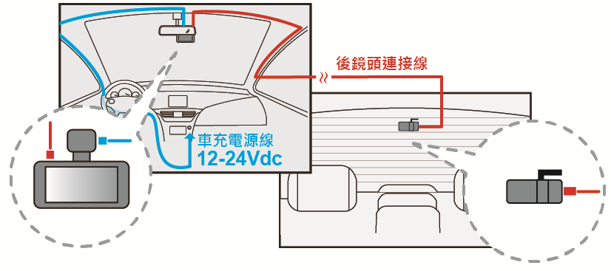

**1. Clean the windscreen**

* Clean both the inner and outer glass for the best image quality.
* Attach the holder to the windscreen

**2. Connect the mount to the camera**

* Attach the mount securely to the camera
* Insert MicroSD card

**3. Camera installation**

* Peel off the holder cover
* Find a place where the location won't disturb you while driving
* It is recommended to place the camera behind the rear view mirror without obstructing the lens or camera functions
* Push the holder properly against the glass

**4. Installing the power adapter**

* If you haven't already done so, plug the power adapter into your car's power socket
* Insert the Micro USB connector into the car camera port and insert the power adapter into the cigarette lighter socket of your car
* Wiring can be hidden around the perimeter of the windshield or rubber lines

**5. Angle setting**

* The dashcam is adjustable with a rotary movement that can be released by pressing and holding the release button on the bracket
* The angle should be slightly below the horizon line to minimize glare

**6. Remove the lens protection film**

**Your camera is now ready for daily use**

|  |  |
| --- | --- |
| C:\Documents and Settings\sophie\桌面\無標題-1.eps | *Warning:*   * *Always use the supplied car power adapter to prevent unexpected damage.* * *If grease marks, fingerprints, or smudges are found on the outer/interior windshield of the car, clean it or put it on an unaffected area. Stains may degrade the recording quality or cause the bracket to become unstable.* * *DOD Tech recommends setting the G-sensor to a low value.* |

**Everyday use**

Your camera will automatically turn on and start recording when it starts receiving power. When the memory card is full, the camcorder overwrites the oldest video recordings by default (loop recording).

**Continuous electrical output**

If your camera is continuously charged, it will not switch off when the car is switched off. To turn off the camera in this case, simply disconnect the Micro USB power cable

|  |  |
| --- | --- |
| *C:\Documents and Settings\sophie\桌面\無標題-1.eps* | *The camera can be switched on while you are parked so you can capture video when you are away. The "Continuous Power Off" feature slowly drains your vehicle's battery and may eventually prevent it from starting.* |

**Video directory**

Videos are stored on the memory card and in internal storage, normal videos are stored in the trunk directory and protected files are stored in the "RO" (read-only) file. The "F" folder indicates videos from the front camera and "R" indicates videos recorded from the rear camera.

**Terminology for front camera videos: 2017_0125_180946_001F**

**Terminology for rear camera videos: 2017_0125_180946_002R**

* Blue in the example above indicates the year/month/day,
* Green indicates the time in 24-hour format including seconds
* Orange indicates the use of a front (F) or rear (R) camera
* The number before the orange letter indicates the serial number of the recorded video

Mobile browser \ DOD DashCam app

Control the camera, download recorded videos and photos, and watch the live view in real time through your smart

equipment.

* **This feature is only available for models with WiFi.**

**Download**

Download and install the DOD DashCam app from GooglePlay or App

Store on your smart device

|  |  |
| --- | --- |
|  | |
| Android | iOS |

|  |
| --- |
| *Note: The DOD Dashcam app requires Android 4.5 / iOS 7 (or later).* |

**Wi-Fi connection**

Press the Wi-Fi button on the camera to select 5GHz/2.4GHz → turn on AP mode → use your mobile phone or tablet to connect to the camera's Wi-Fi and enter the password →

default password: 12345678

|  |  |  |
| --- | --- | --- |
| AP mode  SSID:DOD_GS980D_XXXXXXXXXXX  PWA2:12345678  Reset WiFi_OFF |  | **Connecting to a WiFi network**  To exit the WiFi Settings page, press OK. |

When you open the app, click on the camera icon to enter the camera list, select your model to complete the connection.

**Scan the QR code to access a video describing the features of the DOD APP**

|  |  |
| --- | --- |
| goo.gl/GtFyod |  |
| *Warning:*   * *The Wifi password is only required once during setup.* * *The Wi-Fi range between the camera and the smart device is limited to approximately 1 meter* * Wi-Fi connectivity varies depending on distance and environment, with a recommended range of one metre*.* | |
|  | |

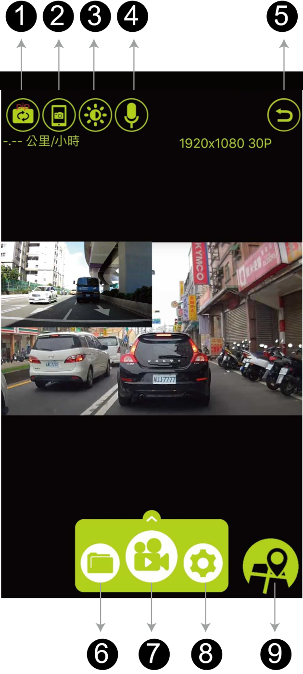

1. front and rear camera switching
2. taking a picture
3. brightness adjustment
4. microphone - on/off sound recording
5. Return to
6. viewing files
7. switch video recording on/off
8. Settings
9. google maps

Menus and recording settings

Press the MENU button **[ ]** to access the settings.

* Formatting a memory card

Completely erases all files, including locked shots, from the SD card and optimizes the card for recording.

* Resolution setting

Sets the qulality of the record.

* Recording loops

The loops can be set to a length of 1,3 or 5 minutes. Video recordings of the selected length will be recorded on the memory card. When the memory card is full, the oldest files are overwritten (except for locked clips).

* Sound recording

You can turn audio recording on/off

* GPS signal status display
* Speed and volume settings
* G -Sensor

Measures impact forces. The "low to high" settings determine the amount of force required to lock the file from overwriting. When the function is triggered, the currently recording video is locked and the file is saved in the "RO" directory.*Recommended settings: low*

* EV modification

Adjusts the video brightness

Video is too bright? Adjust the interface -1 to -3.

Video too dark ? Set the interface +1 to +3.

*Recommended setting: 0*

* Setting the number plate
* Parking (Default:Off)

1. When the function is switched on, the dashboard camera automatically switches to parking view if the vehicle is stationary for more than 10 minutes.
2. Automatically records a 1-minute video when motion is detected within the camera's range.
3. When excessive impact force is sensed by the G-sensor, it automatically records and locks the 1-minute video.
4. The unit will return to normal recording mode if the vehicle moves continuously for 3 seconds or more.
5. The LED flashes when parking mode is activated. All LEDs flash together when a video file is being recorded during parking mode.

|  |  |
| --- | --- |
| C:\Documents and Settings\sophie\桌面\無標題-1.eps | *Remark:*  *The parking mode requires consistent power from the vehicle battery. (It is recommended to use the optional DOD DP4 kit, which is equipped with low voltage protection to prevent the battery from discharging.*  *Check that the G sensor is activated (Recommended setting: medium)*  *Parking mode automatically disables GPS localization and resumes when you switch to normal recording mode.*  *Note: The parking tracking function is not activated when the smart device is connected to the camera* |

* Screen rotation

Rotates the recorded image 180° when the camera is mounted on the dashboard instead of the windscreen.

* Rear screen rotation

Rotates the recorded image 180° when the camera is mounted on the dashboard instead of the windscreen.

Setting up the system

Press the MENU button **[ ]** twice to access the settings.

* WiFi

There is a 5GHz/2.4GHz option.

* Language settings
* Date and time
* Time zone setting
* Sounds

You can turn the key tone on/off

* Preset value

Restores factory settings.

* Firmware version

Displays the model name and the current firmware version.

Playing files

Press the MENU button **[ ]** 3 times to enter playback.

* Select from: locked/general/photos/all
* Select the type of file you want to play and press [**OK**]
* Select the file you want to play and press [**OK**]
* Press OK again to stop playback
* Press [ ] to return to the previous page/offer
* During playback, press the directional arrows to rewind the file