# **Mini Wifi P2P pinhole with focus on text**

# 

1. On/off button
2. LED indicators
3. Reset button
4. Micro USB port
5. Memory card slot

## Launching the camera

Hold the power button for about 3 seconds. The blue indicator lights up and after a while the green indicator lights up. The green indicator starts flashing after a while, which signals the camera to turn on and start in AP mode. In AP mode, the camera broadcasts its own wifi network, which you can connect to.

To turn off the camera, hold down the power button for about 3 seconds.

## Charging

Plug the included USB cable into the micro USB port of the camera and connect the other end of the cable to the USB adapter in a socket with an output of 5V 1A or 2A (not included in the package) or in the USB port of the computer. When charging via a computer, charging may take longer depending on the performance of the computer's USB port. By default, leave the camera connected to charge for about 2-3 hours.

## Reset

If the camera is not working properly, hold the rest button for about 10 seconds while the camera is on. The indicators go out during the reset and then turn on automatically, which signals the camera to reset. By resetting the camera, the AP mode is set again, when the camera broadcasts its own wifi network.

# **Focusing the lens**

The camera allows you to change the focus of the lens, so you can adjust the lens to be able to capture text from a short distance. Rotating the camera lens (yellow part in the picture) will change the focus of the camera image. **Be very careful while changing the focus to avoid damaging the camera. Also pay attention to the cable that leads to the lens. Do not bend the cable with force to avoid internal damage, which would result in the camera not working or changing the colors in the image.**

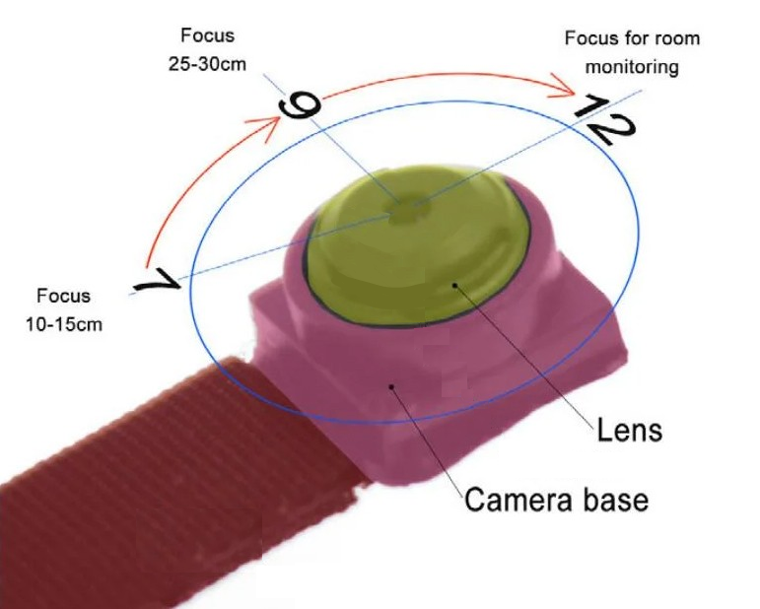

## Spy earphone

To activate the spy handset, it is necessary to insert a battery. Unscrew the black cap of the handset. Then insert the batteries into the handset and screw the cap back on. Be careful if you insert the battery correctly into the device so as not to short-circuit the handset. See where the positive (+) and negative (-) poles are on the battery. Once the battery is inserted, the handset will activate and make a beeping sound to indicate that the handset is on. This noise will not be heard during communication.

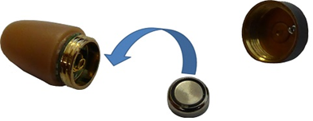

When closing the battery in the earphones, make sure that the cap is correctly fitted. There must be no free space between the handset and the cover.

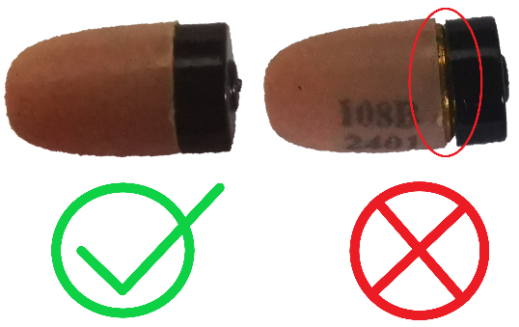

Place the white antenna of the camera no more than 15 cm from the handset to ensure a sufficient signal from the camera for communication.

# **HDCameraPro application**

Download an app called HDCameraPro via google to your mobile phone play or app hundred for apple . You can also use the QR code below to download the app.

|  |  |  |
| --- | --- | --- |
|  |  |  |
| ANDROID | HDCameraPro | **iOS** |

## Assigning the camera to the application

Turn on the camera by holding down the power button. Wait approximately 1 minute for the camera to fully activate. Then open available Wi-Fi networks on your mobile phone . In the settings wifi networks to search for available wifi networks. When your phone displays a wifi network named HD- Camera -xxx or HW-xxx, connect to this network.

Make sure you have mobile data turned off and location services turned on in your mobile phone.

After connecting to the camera, launch the application. Enable the necessary settings when you first launch the application.

The application recognizes your camera automatically, but with some phones it may happen that the camera is not assigned and it will be necessary to connect the camera to the application manually.

### Manual camera assignment

On the home page of the application, click the " Add device" button or click the + icon in the upper right corner of the application. Then select the "Device LAN add " option. The application searches for a connected camera via Wi-Fi . Then click on the found device and the camera will be added to the app.

Obrázok, na ktorom je text, diagram, softvér, počítačová ikona

Automaticky generovaný popis

## Connecting the camera to the wifi router

When you have the camera connected to the applications, you can also connect it to a wifi router so that you can monitor the camera remotely via the Internet. Click the + icon in the upper right corner of the application and select the first option “ Equipment AP distribution network ".

Obrázok, na ktorom je text, snímka obrazovky, softvér, počítačová ikona

Automaticky generovaný popis

the Wi-Fi router will open . These settings consist of 4 steps.

Step 1: Verify that the device is properly turned on. In this step, verify that the green camera indicator is lit. If yes, you can continue to the next step.

Step 2: Check whether you are correctly connected to the camera's wifi network. Your mobile phone must be connected to the wifi network that the camera broadcasts (HD- Camera -xxx or HW-xxx). If yes, you can go to the next step.

3rd step: Choosing the wifi network to which you want to connect the camera so that you can monitor it remotely. In this step, it is important that you connect the device only to a Wi-Fi network with 2.4GHz. **The device is not compatible with the 5GHz network.** After selecting a wifi network, enter the correct password for that network and complete the setup.

Step 4: After selecting a Wi-Fi network, the camera will automatically connect to the selected Wi-Fi network. This connection may take some time. After a successful connection, the application will return to the home screen.

Obrázok, na ktorom je text, snímka obrazovky, diagram, dizajn

Automaticky generovaný popis

## Monitoring the camera image

On the home page, click on the camera image. The application will open the camera preview, where you can see what the legal camera captures. In this interface, you also have access to additional functions such as communication, listening or recording of a streaming image.

Obrázok, na ktorom je text, snímka obrazovky, softvér, multimédiá

Automaticky generovaný popis

### Additional functions

Obrázok, na ktorom je text, snímka obrazovky, softvér, multimédiá

Automaticky generovaný popis

1. Live stream from the camera
2. Communication to the spy handset
3. Creating a snapshot from a live stream
4. Creating a video from a live stream
5. live stream recordings
6. Notifications
7. Wiretapping
8. Change the resolution of the streaming image
9. Turn on / off the digital backlight
10. Full screen display
11. Turn on / off the LED indicators of the camera
12. Mirror image rotation
13. Horizontal image rotation

## Settings

To enter the settings, click on the gear wheel icon located in the upper right corner while watching the camera image or on the home page of the application when the camera is connected.

Obrázok, na ktorom je text, snímka obrazovky, softvér, multimédiá

Automaticky generovaný popis

### Device information​

In these settings, you will find device information. Here you can change, for example, the name of the camera that will be displayed in the application or the password for accessing the camera. Here you will also find the UID code of the camera, which is used to connect to the application on another device.

Obrázok, na ktorom je text, snímka obrazovky, diagram, rovnobežný

Automaticky generovaný popis

### Motion detection ( Warning alarm settings )

The camera allows you to record an image on a memory card in case of movement in front of the lens. In this setting, you can activate this function and choose motion sensitivity. You can also activate repeated notifications after certain minute intervals.

Obrázok, na ktorom je text, snímka obrazovky, dizajn

Automaticky generovaný popis

### Digital night vision settings ( Night vision settings )

Night vision settings are only available if the camera is connected to a wifi router. The settings allow you to activate different night video modes. However, the camera does not physically have any IR LEDs for night vision, and this function is only for digital image change.

### Recording settings

In the recording settings, you can change the mode in which the camera will record recordings to the memory card. When choosing full this time the camera will be continuously. In the case of motion-only recording, it is necessary to activate the motion detection functions and select the recording mode as an alarm.

You can also set the length of saved records. By default, the camera creates 10-minute recordings.

Obrázok, na ktorom je text, snímka obrazovky, softvér, webová stránka

Automaticky generovaný popis

### Other settings

In the other settings, you can find information about the size of the memory card. Here it is also possible to set the time format 24H / 12H and have the camera time synchronized with the mobile phone.

Obrázok, na ktorom je text, snímka obrazovky, softvér, diagram

Automaticky generovaný popis

## Package contents

1x Camera   
1x Spy handset 1x Set of buttons   
1x Battery for spy handset 1x Manual

## FAQ

1. **Unable to load the camera image after starting the application?**

If it is not possible to load the image from the camera, even if you are connected to the wifi network that the camera broadcasts, then it is necessary to reboot the camera through the application. Click on the gear icon to go to the camera settings. Then click on Reboot at the bottom the device. The device is then completely reset. Turn off the application so that it does not run in the background of the phone. Then connect to the camera's wifi network. Launch the app and start the live stream of the camera. If the image does not load, go to the home page of the application and click on the refresh arrow icon . Subsequently, the image from the camera will be loaded.

Obrázok, na ktorom je text, snímka obrazovky, softvér, operačný systém

Automaticky generovaný popis

**!!!The seller bears no responsibility in case of misuse of these products for illegal purposes. Before use, it is important to familiarize yourself with the conditions (law, technical regulations, decrees, etc.) for operating the products in the given country!!!** !

**Return guarantee within the statutory period of 14 days from purchase, does not apply to micro products headphones , headphones for health protection and hygienic reasons. ( section § 7 et seq . of Act No. 102/2014 Coll .)**

**Country of origin** - PRC **Manufacturer** - **Olyeem Electronics Ltd** ,   
**Importer** - Media Leaders sro Dlhá 4, 974 05 B. Bystrica, www.cool-mania.eu, [info@cool-mania.eu](mailto:info@cool-mania.eu)

Ce-logo

### 