# **Mini Wifi P2P pinhole with text focus**

# 

1. On/Off button
2. LED indicators
3. Reset button
4. Micro USB port
5. Memory card slot

## Starting the camera

Hold the power button for approximately 3 seconds. The blue indicator lights up and after a moment the green indicator lights up. The green indicator will flash after a moment to indicate the camera is powered on and running in AP mode. In AP mode, the camera broadcasts its own wifi network that you can connect to.

To turn off the camera, hold the power button for approximately 3 seconds.

## Charging

Plug the included USB cable into the camera's micro USB port and connect the other end of the cable to a USB adapter to a 5V 1A or 2A outlet (not included) or to a USB port on your computer. If charging via computer, charging may take longer depending on the power of the computer's USB port. As standard, leave the camera connected for charging for approximately 2-3 hours.

## Reset

If the camera does not work properly, hold the rest button for approximately 10 seconds while the camera is on. The indicators will turn off during the reset and then automatically turn on to signal the camera to reset. Resetting the camera again sets the AP mode, where the camera broadcasts its own wifi network.

# **Lens alignment**

The camera allows you to change the focus of the lens, so you can adjust the lens to be able to capture text from a short distance. Turning the camera lens (yellow part in the picture) will change the focus of the camera image. **Be very careful not to damage the camera while changing the focus. Also pay attention to the cables that leads to the lens. Do not forcefully bend the cable to avoid internal damage resulting in the camera not working or the colors in the image changing.**

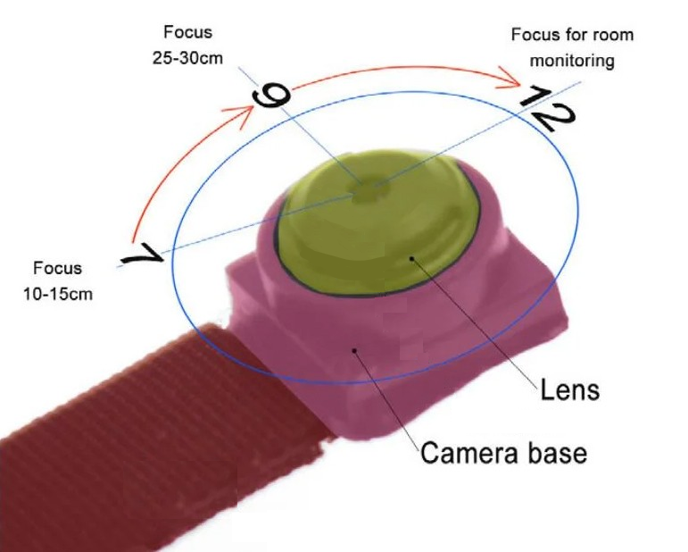

## Spy earpiece

To activate the spy handset, you need to insert the battery. Unscrew the black cap of the handset. Then insert the batteries into the handset and screw the cap back on. Make sure you insert the battery correctly into the device so as not to short circuit the handset. Note where the positive (+) and negative (-) poles are on the battery. When the battery is inserted, the handset will activate and make a noise to signal the handset to start. This noise will not be heard during communication.

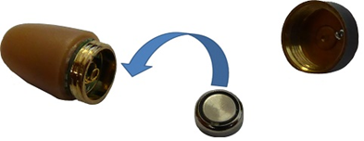

When closing the battery in the earpiece, make sure that the cap is correctly fitted. There must be no free space between the handset and the cap.

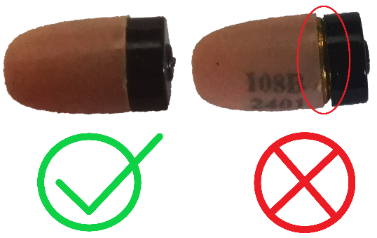

Place the white antenna of the camera no more than 15 cm from the handset to ensure sufficient signal from the camera for communication.

# **HDCameraPro app**

Download the app called HDCameraPro to your mobile phone via google play or the apple app store. You can also use the QR code below to download the app.

|  |  |  |
| --- | --- | --- |
|  |  |  |
| ANDROID | HDCameraPro | **IOS** |

## Assign a camera to an application

Turn on the camera by holding down the power button. Wait approximately 1 minute for the camera to fully activate. Then open the available wifi networks on your mobile phone. In the wifi network settings, search for available wifi networks. When your phone shows you a wifi network named HD-Camera-xxx or HW-xxx, connect to this network.

Make sure your mobile phone has mobile data switched off and location services switched on.

Once connected to the camera, launch the app. When you initially launch the app, enable the necessary settings.

The app will automatically recognize your camera, but on some phones the camera may not be assigned and you will need to connect the camera to the app manually.

### Manual camera assignment

On the home page of the app, click the "Add device" button or click the + icon in the top right corner of the app. Then select the "Device LAN add" option. The app will search for the connected camera via wifi. Then click on the found device and the camera will be added to the app.

Obrázok, na ktorom je text, diagram, softvér, počítačová ikona

Automaticky generovaný popis

## Connecting the camera to a wifi router

When you have the camera connected to the app, you can also connect it to a wifi router to monitor the camera remotely over the internet. Click on the + icon in the top right corner of the app and select the first option "Equipment AP distribution network".

Obrázok, na ktorom je text, snímka obrazovky, softvér, počítačová ikona

Automaticky generovaný popis

You will then be taken to the settings for connecting the camera to the wifi router. These settings consist of 4 steps.

Step 1: Verify that the device is properly powered on. In this step, verify that the green camera indicator is lit. If it does then you can proceed to the next step.

Step 2: Make sure you are properly connected to the camera's wifi network. Your mobile phone must be connected to the wifi network that the camera is broadcasting (HD-Camera-xxx or HW-xxx). If so you can go to the next step.

Step 3: Select the wifi network you want to connect the camera to in order to monitor it remotely. In this step, it is important that you only connect the device to a 2.4GHz wifi network. **The device is not compatible with 5GHz network.** After selecting the wifi network, enter the correct password for that network and complete the setup.

Step 4: After selecting the wifi network, the camera will automatically connect to the selected wifi network. This connection may take some time. After successful connection, the application will return back to the home screen.

Obrázok, na ktorom je text, snímka obrazovky, diagram, dizajn

Automaticky generovaný popis

## Camera image tracking

On the home page, click on the camera image. The application will open the camera preview where you will see what the legal camera is capturing. In this interface, you also have access to additional features such as communication, bugging or streaming video recording.

Obrázok, na ktorom je text, snímka obrazovky, softvér, multimédiá

Automaticky generovaný popis

### Additional features

Obrázok, na ktorom je text, snímka obrazovky, softvér, multimédiá

Automaticky generovaný popis

1. Live stream from the camera
2. Communication to spy earpiece
3. Creating a livestream image
4. Creating a live stream video
5. Playback of saved livestream recordings
6. Alerts
7. Eavesdropping
8. Change the resolution of the streamed image
9. Digital illuminator on/off
10. Full screen display
11. Turning on/off the camera's LED indicators
12. Mirror image rotation
13. Horizontal image rotation

## Settings

To access the settings, click on the gear icon located in the top right corner while viewing the camera image or on the home page of the app when the camera is connected.

Obrázok, na ktorom je text, snímka obrazovky, softvér, multimédiá

Automaticky generovaný popis

### Device information

In these settings, you will find information about the device. For example, you can change the name of the camera that will be displayed in the app or the password to access the camera. You will also find the UID code of the camera, which is used to connect to the app on another device.

Obrázok, na ktorom je text, snímka obrazovky, diagram, rovnobežný

Automaticky generovaný popis

### Motion detection (Warning alarm settings)

The camera allows you to record an image to a memory card if motion is detected in front of the lens. In this setting, you can activate this function and select the motion sensitivity. You can also activate repeated alerts after certain minute intervals.

Obrázok, na ktorom je text, snímka obrazovky, dizajn

Automaticky generovaný popis

### Digital night vision settings (Night vision setting)

Night vision settings are only available if the camera is connected to a wifi router. The settings allow you to activate different night video modes. However, the camera has no physical IR LED for night vision and this feature is only for digital image alteration.

### Recording settings (Recording settings)

In the recording settings, you can change the mode in which the camera will record to the memory card. When full time is selected, the camera will record continuously. In the case of motion-only recording, you need to activate the motion detection functions and select the recording mode to alarm.

You can also set the length of the saved records. By default, the camera produces 10-minute recordings.

Obrázok, na ktorom je text, snímka obrazovky, softvér, webová stránka

Automaticky generovaný popis

### Other settings

In the other settings, you will find the size of the memory card. Here you can also set the time format 24H / 12H and have the camera time synchronized with your mobile phone.

Obrázok, na ktorom je text, snímka obrazovky, softvér, diagram

Automaticky generovaný popis

## Contents of the package

1x Camera   
1x Spy earpiece   
1x Knob set   
1x Spy earpiece battery   
1x Manual

**!!!The seller is not liable in case of misuse of these products for illegal purposes. Before use, it is important to familiarize yourself with the conditions (law, technical regulations, ordinances, etc.) for the operation of the products in the** country!!!!

**The guarantee of return of goods within the statutory period of 14 days from purchase does not apply to products micro earphones, earphones for health protection and hygiene reasons (Sections 7 et seq. of Act No. 102/2014 Coll.).**

**Country of origin** - P.R.C. **Manufacturer** - **Olyeem Electronics Ltd**,  
**Importer** - Media Leaders s.r.o. Dlhá 4, 974 05 B. Bystrica, www.cool-mania.eu, [info@cool-mania.eu](mailto:info@cool-mania.eu)

Ce-logo

### 