Wifi camera in glasses
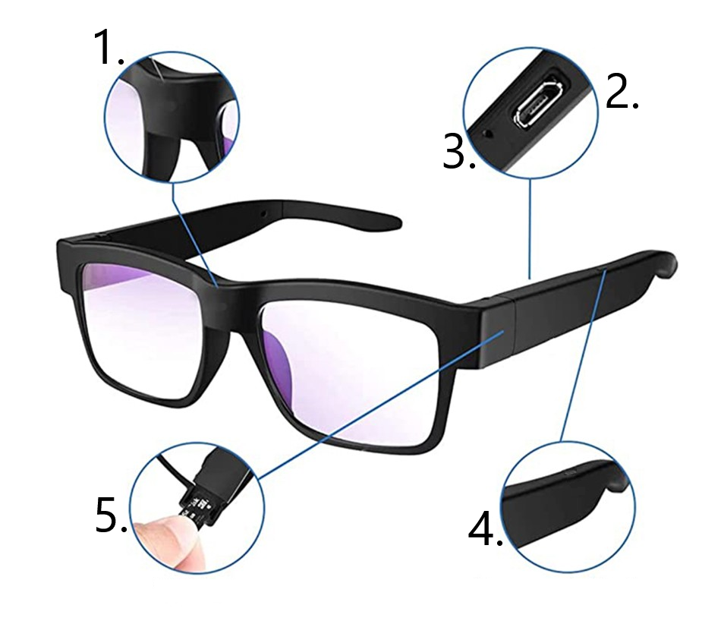

- Camera lens
- Micro USB port
- Reset button
- On/Off button
- Memory card slot

Starting the camera
Hold the power button for approximately 3 seconds. The blue indicator lights up and after a moment the green indicator lights up. The green indicator will flash after a moment to indicate the camera is powered on and running in AP mode. In AP mode, the camera broadcasts its own wifi network that you can connect to.
To turn off the camera, hold the power button for approximately 3 seconds.

Charging
Plug the included USB cable into the camera's micro USB port and connect the other end of the cable to a USB adapter to a 5V 1A or 2A outlet (not included) or to a USB port on your computer. If charging via computer, charging may take longer depending on the power of the computer's USB port. As standard, leave the camera connected for charging for approximately 2-3 hours.

Reset
If the camera does not work properly, hold the rest button for approximately 10 seconds while the camera is on. The indicators will turn off during the reset and then automatically turn on to signal the camera to reset. Resetting the camera again sets the AP mode, where the camera broadcasts its own wifi network. The reset button is located in a small hole near the micro USB port. Pressing the button must be done with a thin needle.

WeiHome app
Download an app called WeiHome to your mobile phone via google play or the apple app store. You can also use the QR code below to download the app.
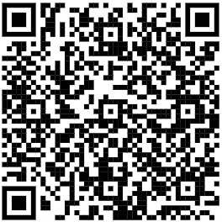 | 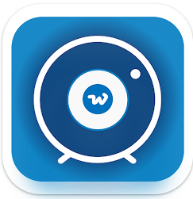 | 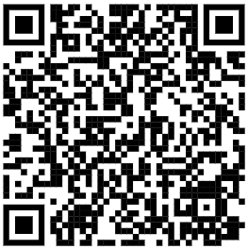
ANDROID | WeiHome | IOS

Create an account in the app
You need to create an account in the app before you can connect your camera to the app. On your mobile phone, turn on mobile data or connect to a wifi network to access the internet. Also turn on your phone's location services. Then open the WeiHome app. In the box, fill in your email that you will be logging into the app with. Confirm the terms and conditions of the app and click "Continue". In the next step, click on "Forgot password" to proceed to account creation. To create an account, click on "Get code", then a verification code will be sent to your email address, which you must enter in the "Verification code" field. Then just enter the password with which you will log in to the application. Click "OK" to complete the account creation.
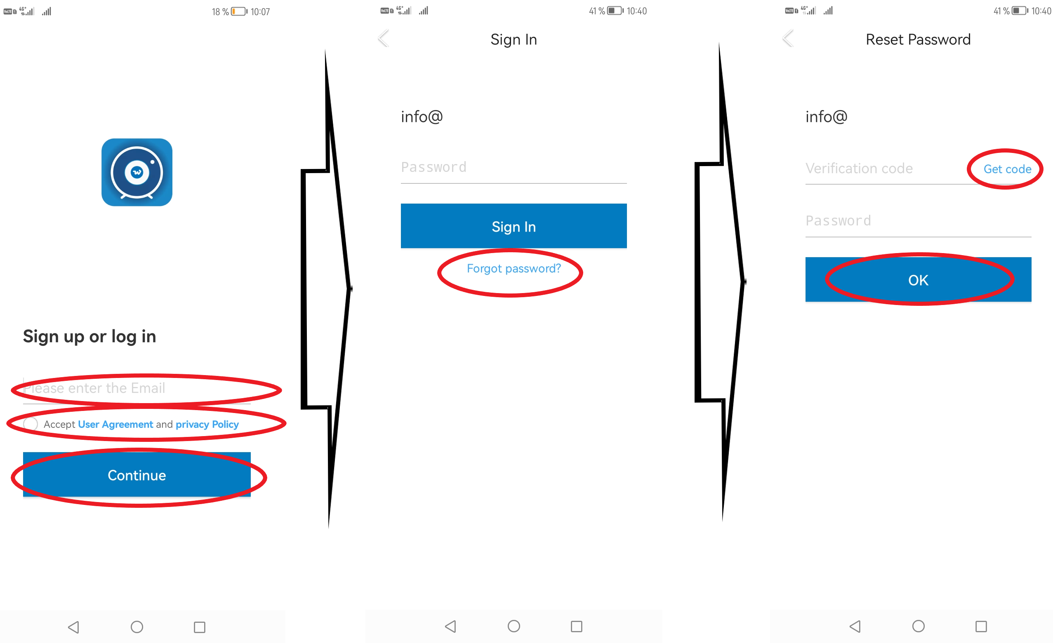

Assign a camera to an application
Turn on the camera by holding down the power button. Wait approximately 1 minute for the camera to fully activate. Then open the available wifi networks on your mobile phone. In the wifi network settings, search for available wifi networks. When your phone shows you a wifi network called CARE-APxxxxxx, connect to this network.
On the home page of the app, click the + icon to add the camera to the app. Then select "Add Device" and select the Wifi-Camera device". Select "Pair by AP Connection" as the pairing mode. In this mode, the app will locate the camera for you within a direct wifi connection to the camera. Therefore, make sure you are connected to the camera's wifi network.
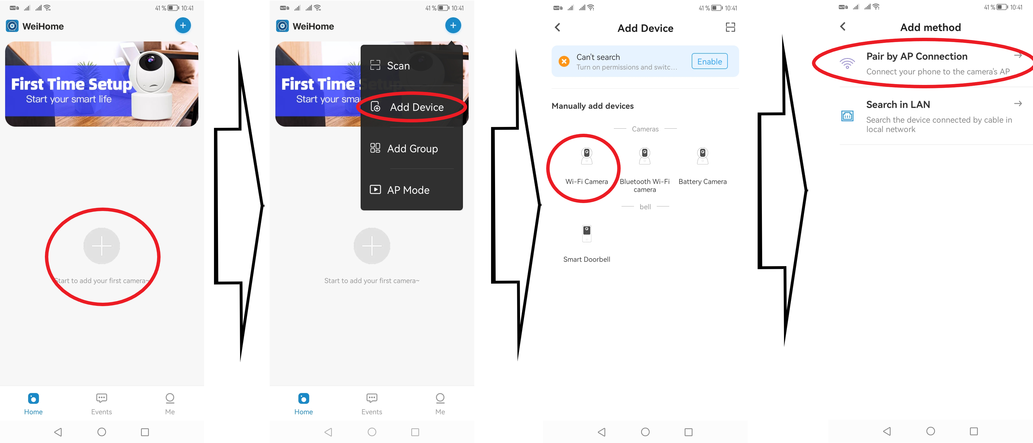
There are 4 steps to pair the camera with the app.
- Check that the green camera indicator is lit. A blinking green indicator indicates that no device is connected to the camera's wifi network. You can then confirm the settings and go to the next step.
- Make sure you are connected to the correct wifi network that the camera is transmitting on. The camera's wifi network starts with the name Care-APxxxxxxxx.
- Wait for the app to load the camera.
- The camera has been assigned to the application.
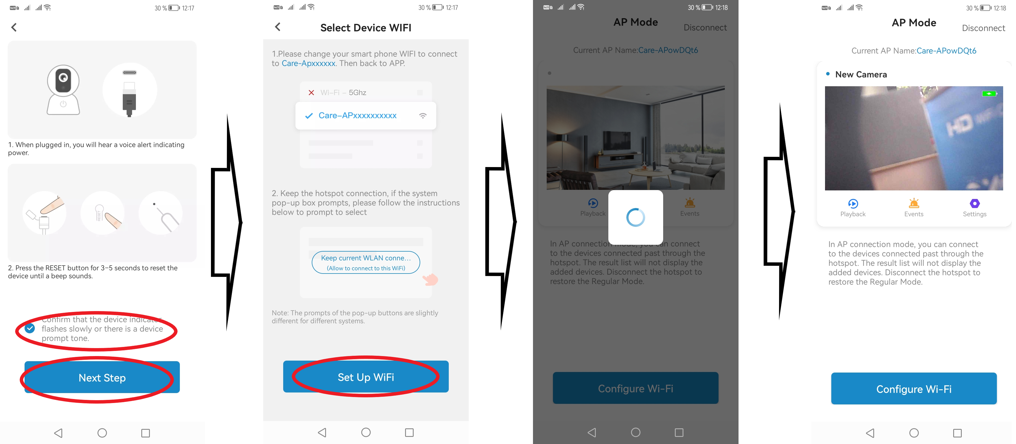

Connecting the camera to a wifi router
When you have the camera connected to the app, you can also connect it to a wifi router so you can monitor the camera remotely over the internet. Click on the "Configure Wi-Fi" button.
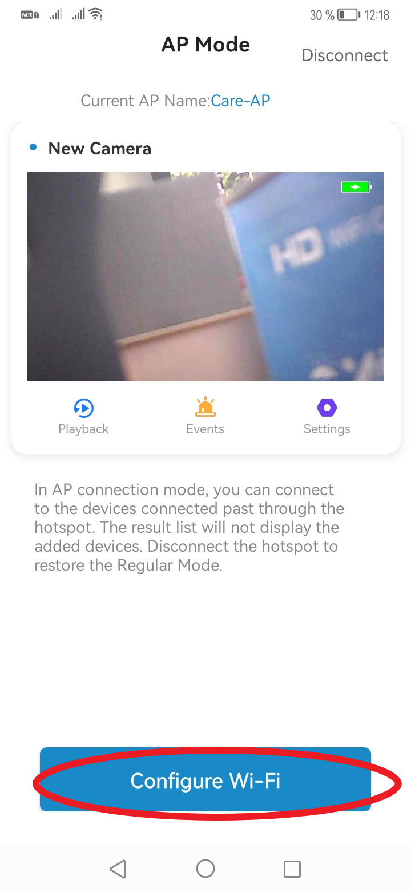
The app will then search for available wifi networks that you can connect the camera to. In this step, it is important that you only connect the device to a wifi network with 2.4GHz. The device is not compatible with a 5GHz network. After selecting the wifi network, enter the correct password for that network and complete the setup. The camera will then connect to the selected wifi router. This connection may take a while. Once the connection is complete, you will be able to name the camera and then monitor it remotely over the internet.
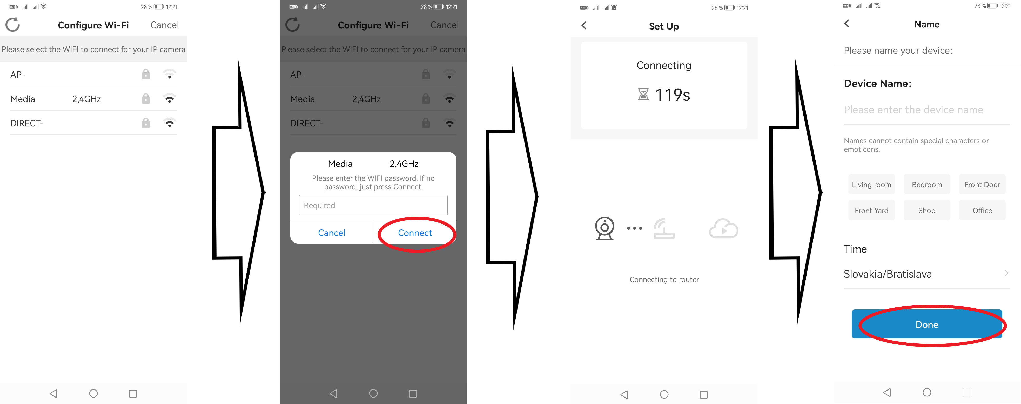

Camera image tracking
On the home page, click on the camera image. The application will open the camera preview where you will see what the legal camera is capturing. In this interface, you also have access to additional features such as, for example, bugging or streaming video recording.
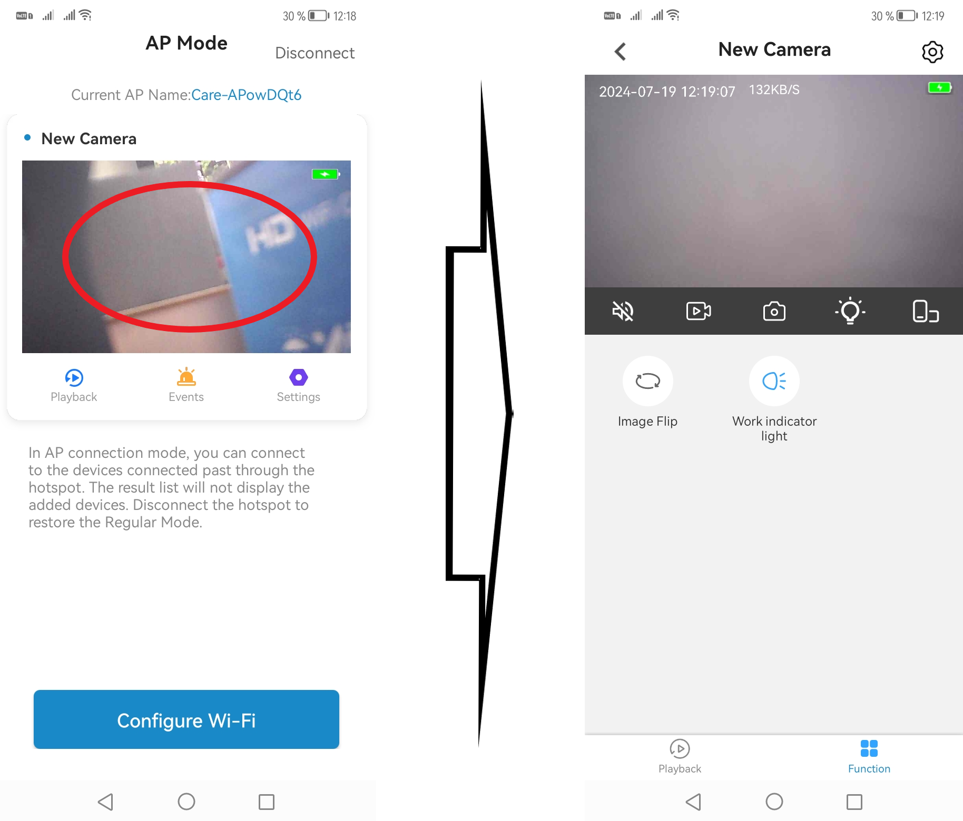

Additional features
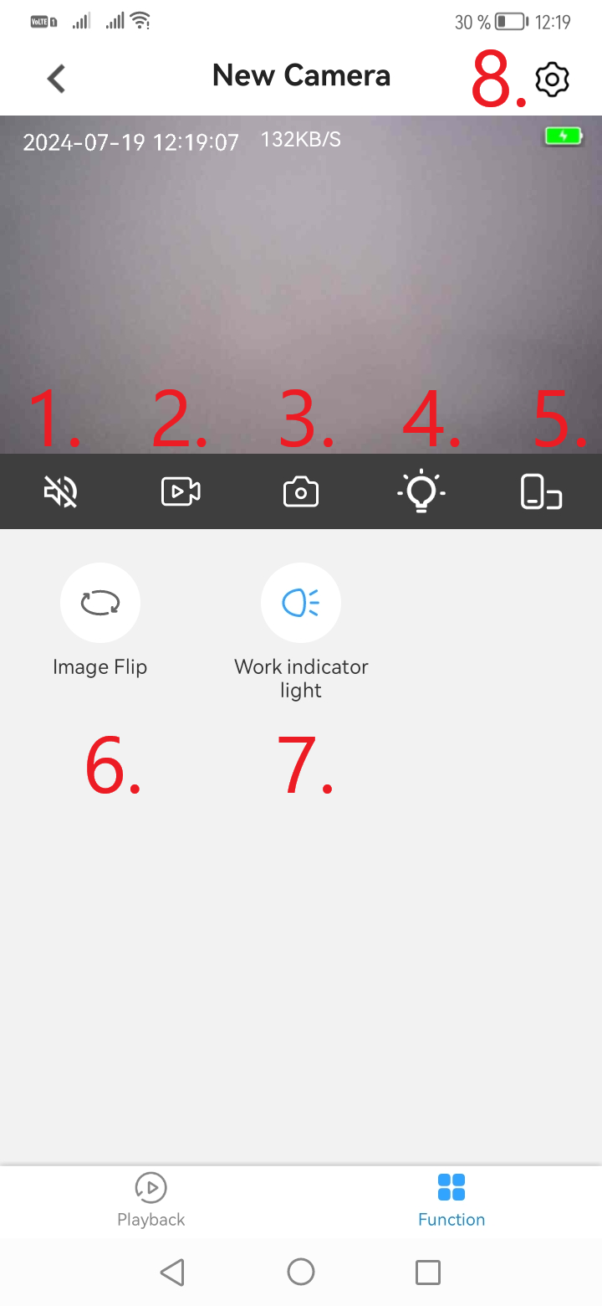

- To activate the intercom
- Streaming video recording
- Snapshot of a streaming image
- Digital night vision
- Full screen mode
- Image rollover
- Deactivating the camera LED indicator
- Settings

Settings
To access the settings, click on the gear icon located in the top right corner while viewing the camera image or on the home page of the app when the camera is connected.
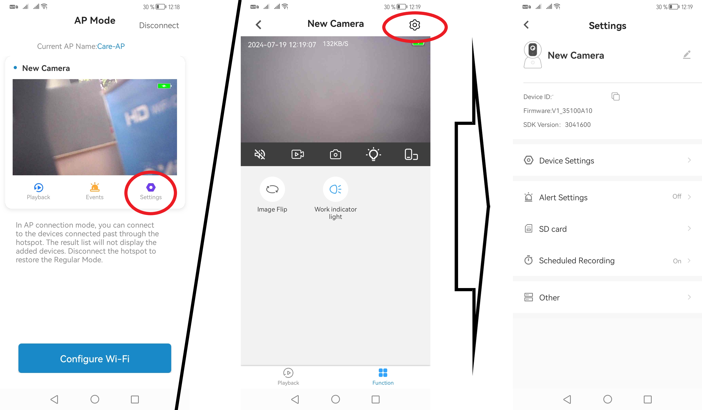

Device Settings (Device Settings)
In these settings, you can turn the camera on or off, activate or deactivate the device's microphone, rotate the captured image. You can turn on or off the LED indicator on the device or activate digital night vision.
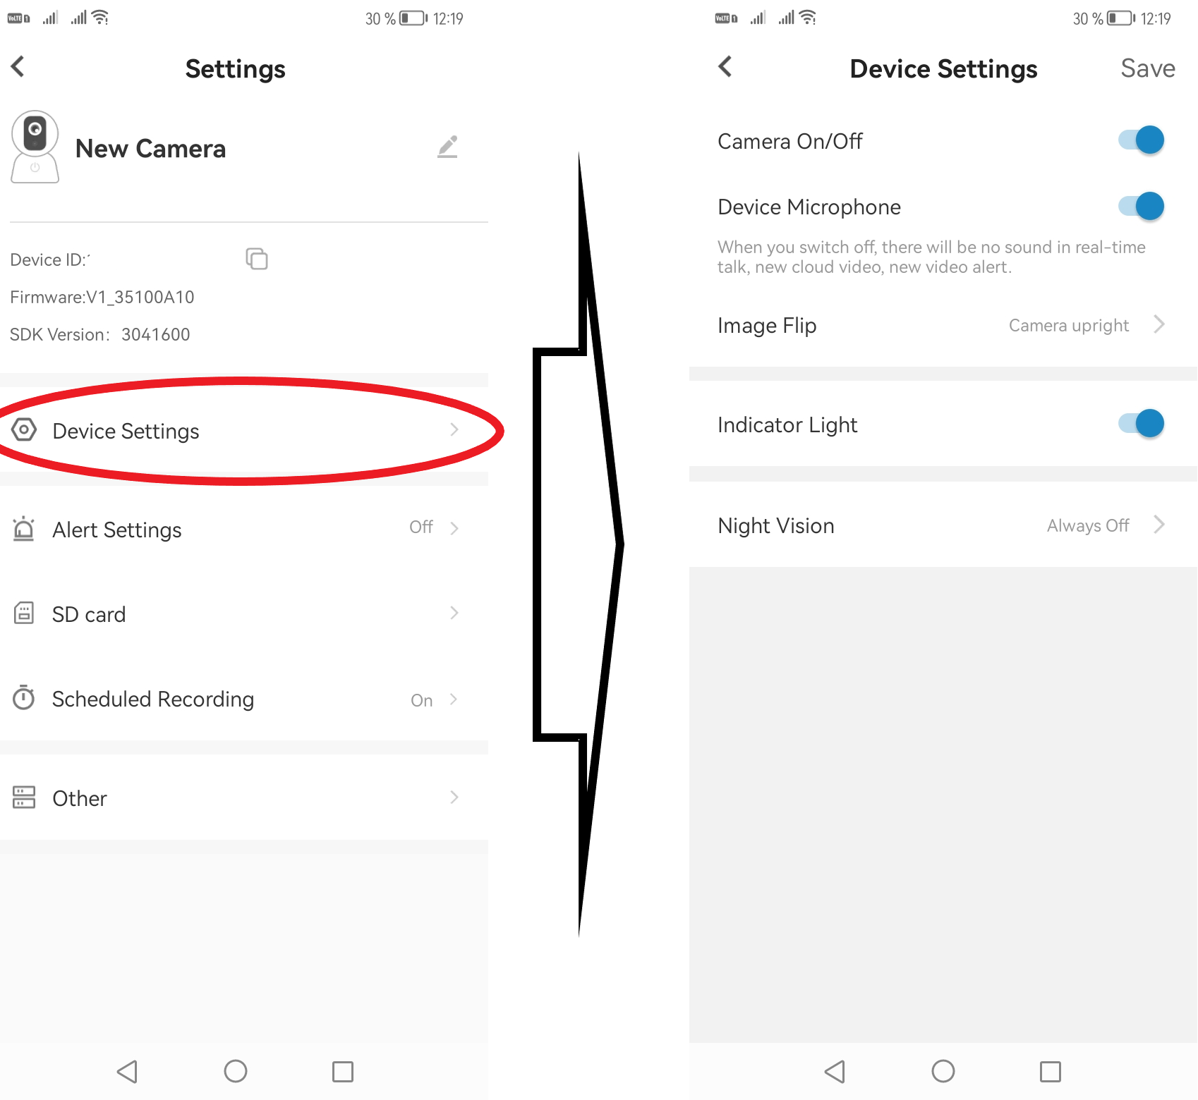

Motion Detection (Alarm Settings)
The camera can record footage to a memory card using motion detection. If the camera detects motion in front of the lens, it will automatically start recording. The video recording is stored on a memory card in the device (card not included). You can activate or deactivate the motion detection function in this setting. You can also set a specific time from when to when the camera should operate in motion detection mode. By setting the sensitivity, you determine the sensitivity of the camera to motion detection.
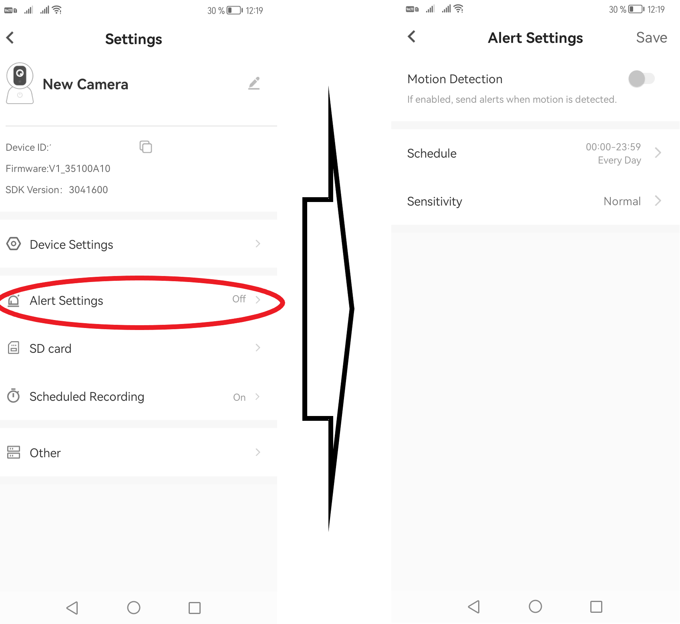

Memory card (SD card)
In this setting, you can see the memory card data. How much space the inserted memory card has free and how much space is full. In these settings, you can also format the memory card remotely.
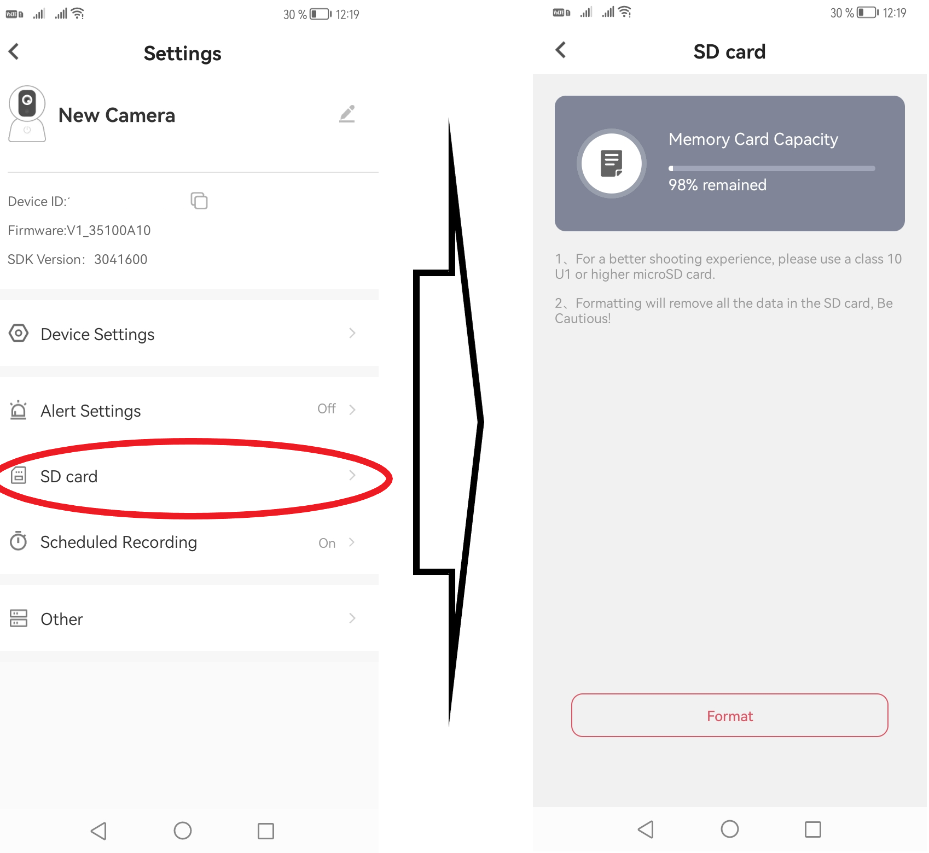

Scheduled Recording
In these settings, you set the recording schedule. That is, you can choose specific times according to which the camera will record. You can specify multiple time intervals.
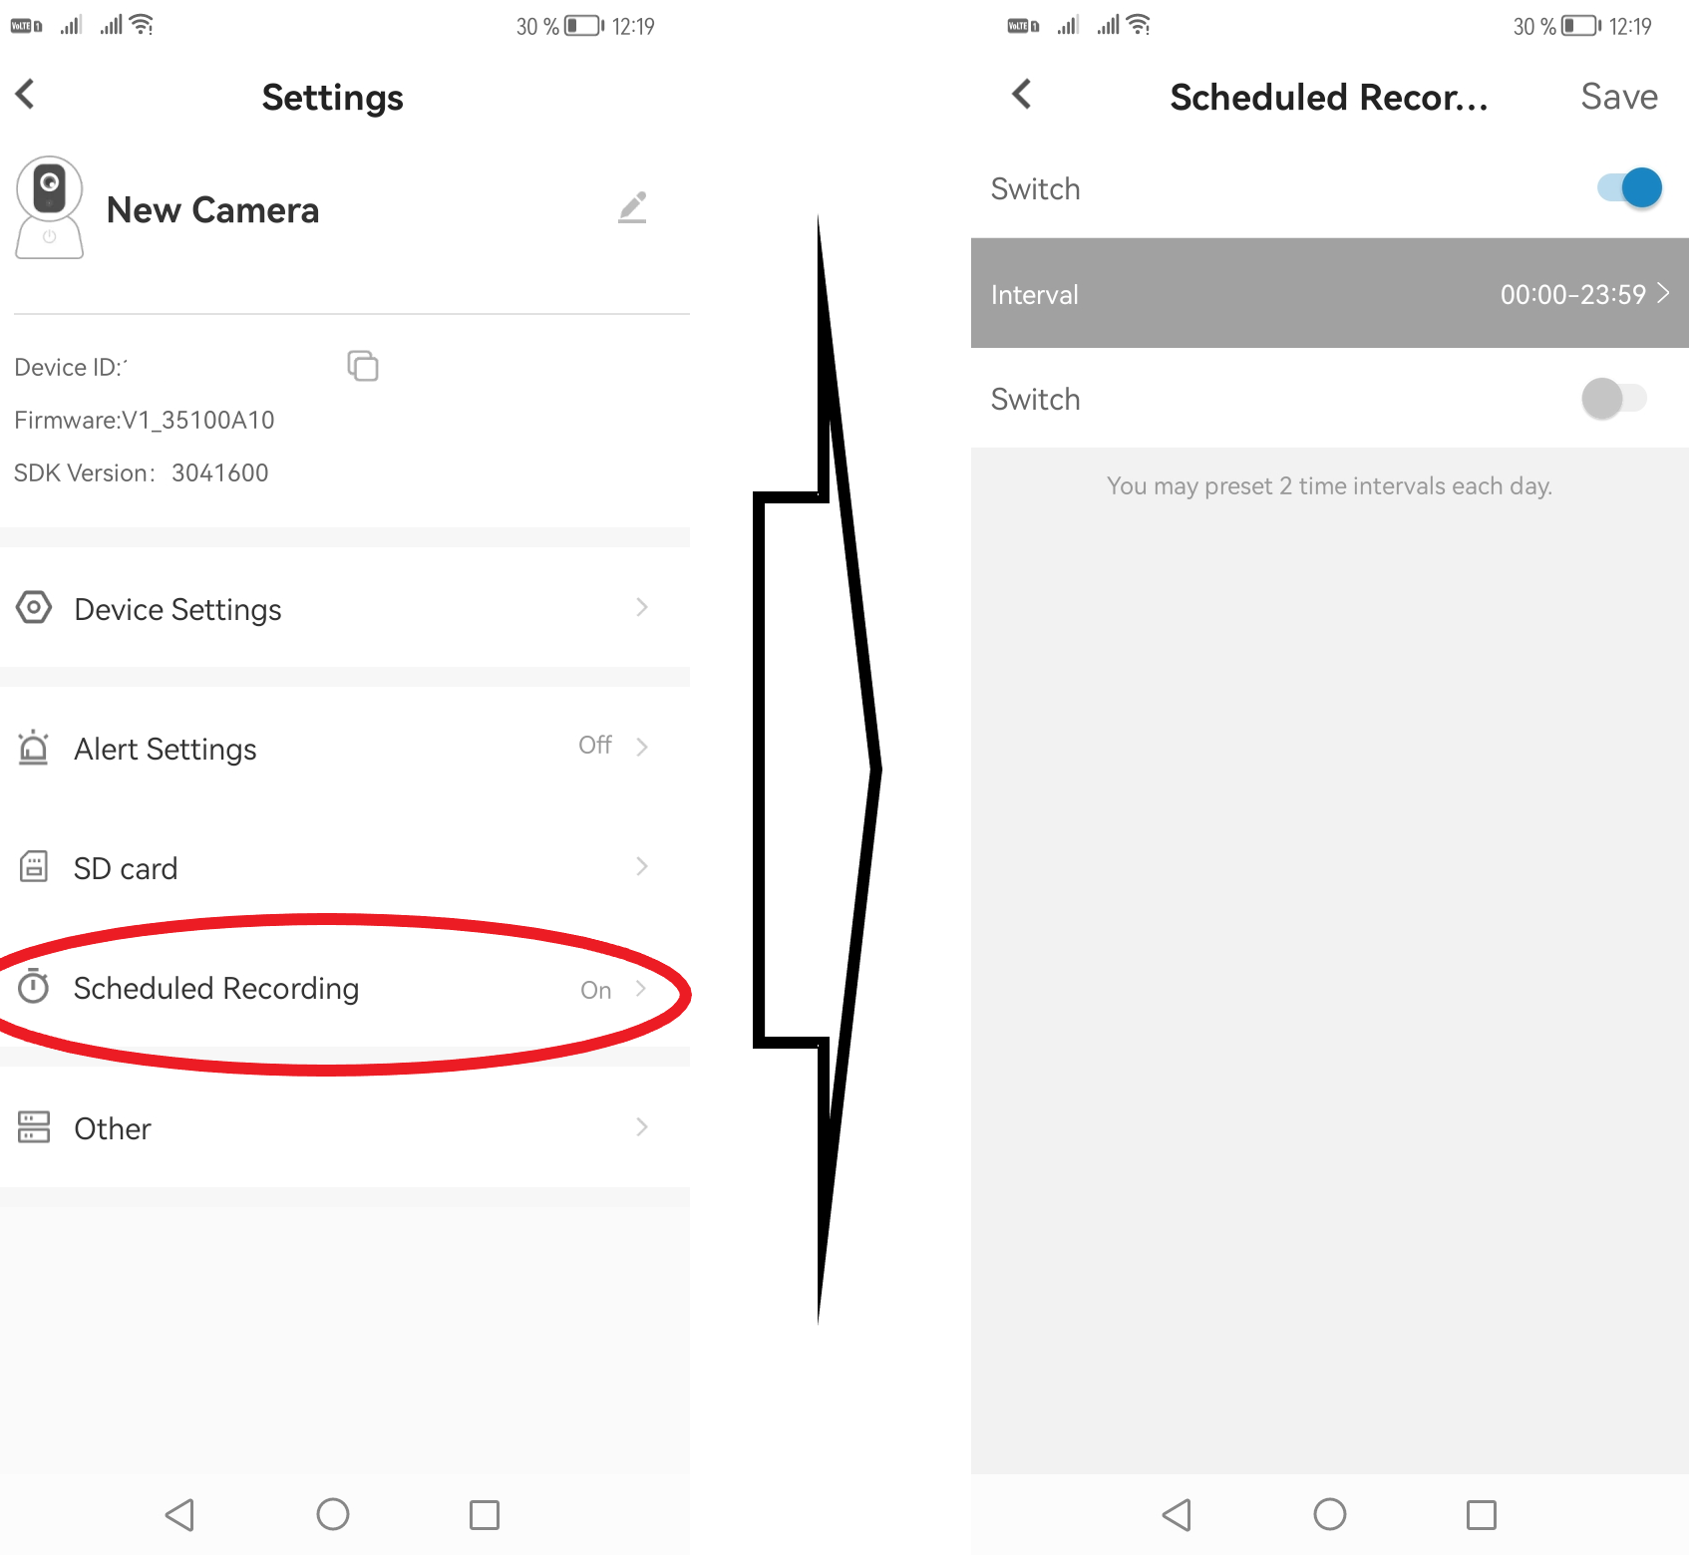

Other settings (Other)
In the other settings, you can remotely reboot the device albeo set the correct date and time, including the time zone.
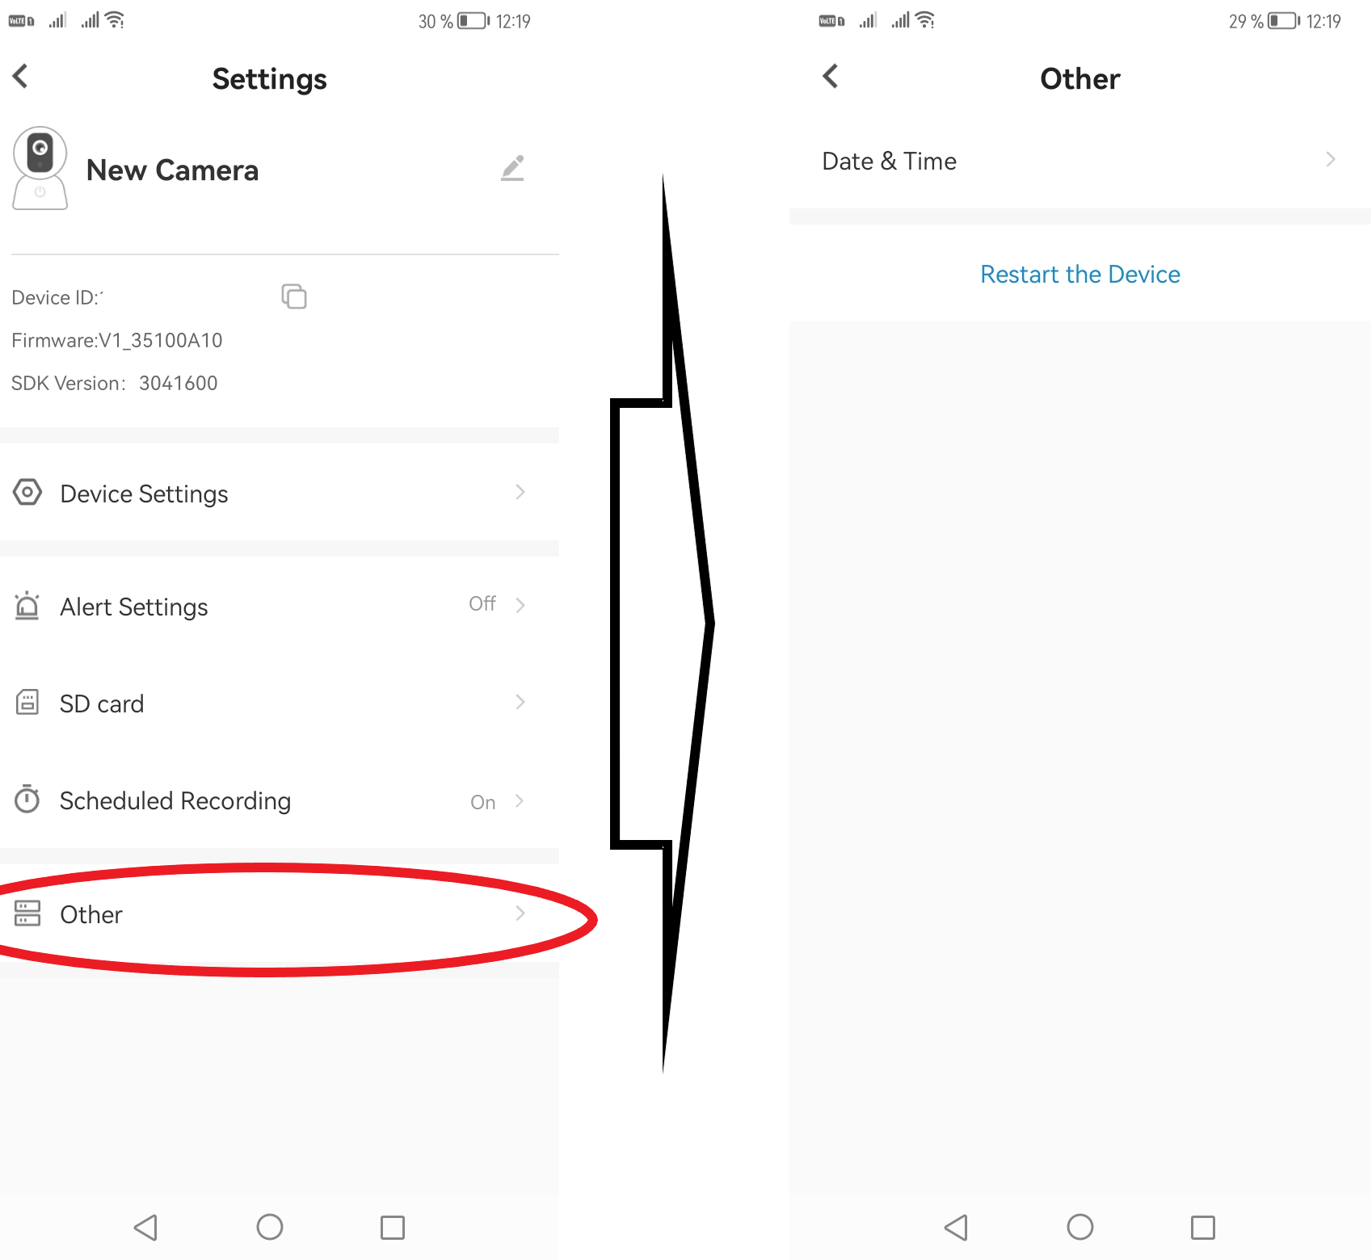

Specifications
Optics | 2.0 MP CMOS
Video resolution | 1920 x 1080p
Sensing | 30fps
Compression | H.264
Video format | AVI
Sensing angle | 70°
Memory card support | microSD cards 8-32GB class 10 and above
Battery | 280 mAh
Battery life | approx. up to 100 minutes (working time)
Charging time | 2-3 hours
Network connection | Wifi
Power | DC-5V
Power cord | Micro USB
Support systems | IOS, Android
Dimensions | 149 mm x 146 mm x 41 mm
Weight | 40 g

Contents of the package
1x WiFi glasses with camera
1x Micro USB cable
1x Cleaning cloth
1x Protective case
1x Manual

!!!The seller is not liable in case of misuse of these products for illegal purposes. Before use, it is important to familiarize yourself with the conditions (law, technical regulations, etc.) for the operation of the products in your country!!!
Country of origin - P.R.C. Media Leaders s.r.o., Dlhá 4, 974 05 Banská Bystrica, Slovakia,
