Instructions for activating the SM card 1NCE
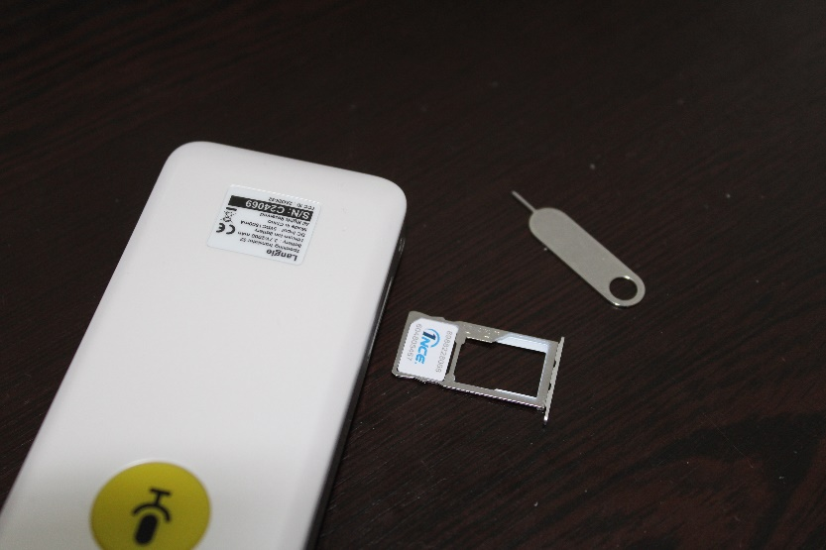
Insert the SiM card into the Langie translator. The SiM card is inserted into the slot that is deeper in Langie. (as shown) This SiM card, or any other card except the original Langie card, will not be displayed by Lange in the Langie SiM settings. So it will not display its number or consumption and expiration time.
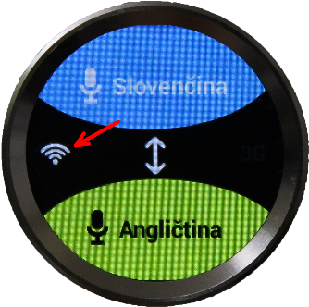If the WiFi icon is on, you need to turn it off as follows:
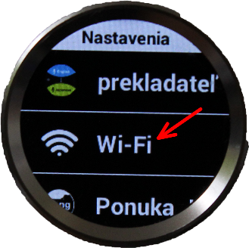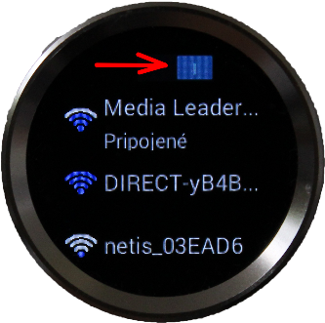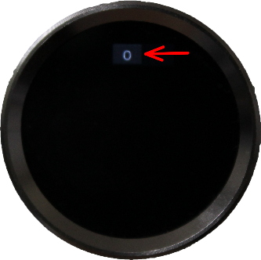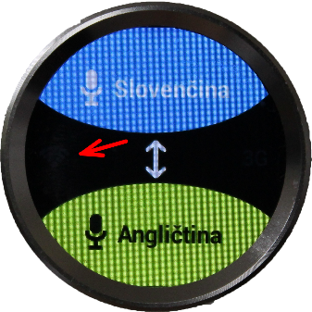

To activate the SiM card you need to type the APN address in the text " iot.1nce.net " into the APN settings in the translator. Single-click to go to the APN settings and select New APN.
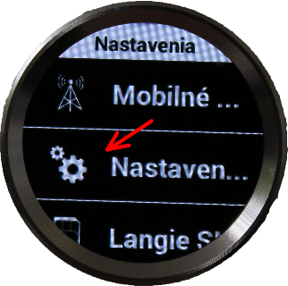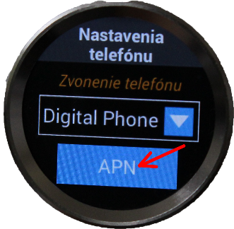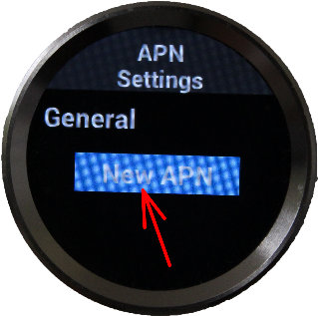
We are only interested in the first two lines with the APN name and APN name. First we click on APN. A keypad appears on the screen like on older push-button mobile phones. We then type in the address iot.1nce.net and confirm OK. Do the same on the second line with the APN name. Then confirm with OK. When we have both lines filled in we scroll all the way down to the bottom where we confirm everything with a big blue OK.
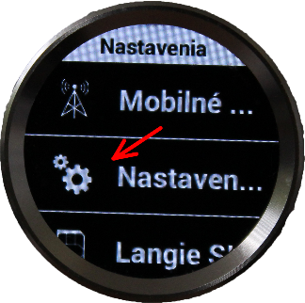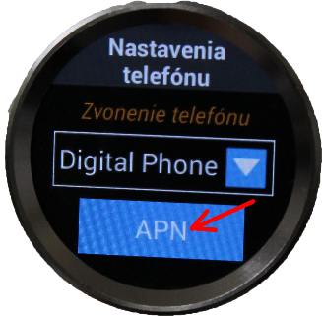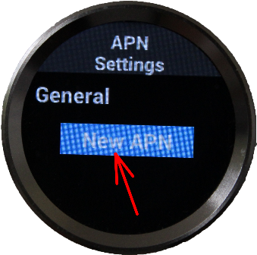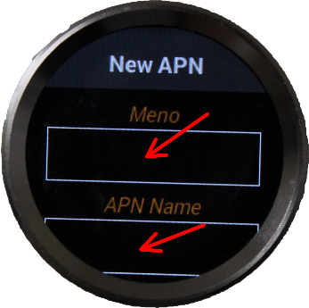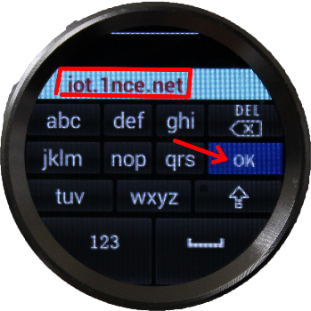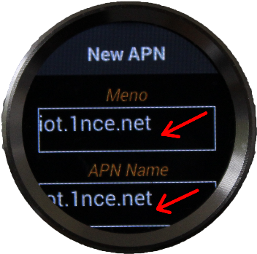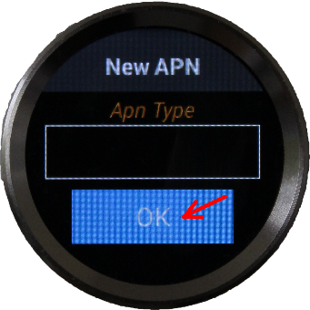

Now we should see the 1nce in blue in the settings and the 3G icon will be lit on the main screen, which means that you are connected to the internet. If it is lit under General iot.1nce.net you have made a mistake somewhere and 3G will not be lit. You need to be careful not to click on the space when entering letters, numbers and dots. The entire address must be without spaces. If you get the name wrong hence iot.1nce.net you can re-enter the address by clicking on New APN.
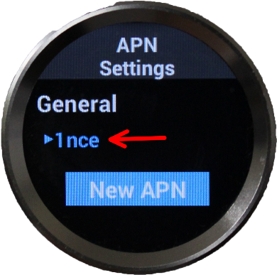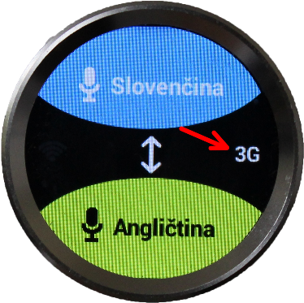

Country of origin - Netherlands. Media Leaders s.r.o., Dlha 4, 974 05 Banská Bystrica, Slovakia


